<https://www.zipjob.com/free-review> : resume review within 48 hours

The purpose of the cover:

Brief

Attention grabbing

Why you are qualified

Create intrigueme

One significant accomplishment. (4 sentences)

Showing how you connect on a personal level with the employer

Tell them how you came to learn what they do is special. Smart/faster

Share what it was like the first time you used their product/service.

Help them understand that life experience has made you feel part of their tribe.

The more personal the better. / create connection

------------

1. make it personal: Dear.. name dear hiring Team, dear hiring manager,
2. Tell them why you picked them
3. Tell them why they should pick you
   1. Look at the top two or three things, how you can add value to business, how?
   2. Throw in a little sneaky line from another great reference you have got to back all of that up
4. Show passion
   1. How much you want it

I would like the opportunity to discuss this application. Use word love instead of like

1. Show kindness
   1. I would just like to wish you all the best of this piece of recruitments
   2. I know recruiting is quite a stressful time and I really hope it is going well as you’d hope

_________________________

Paragraph 1:

1. Who you are
2. Position are you Appling to
3. Where or how you found the opening
4. The title and job ID # number
5. State a brief summary of qualifications or your interests your position

Paragraph 2:

* 1. Discuss your qualifications and achievements
  2. Mention a few examples of quantifiable or measurable achievements in your career
  3. Use compelling language and do not repeat the information in our resume
  4. Try to bring you resume to life.

Paragraph 3:

1. Close it out by saying you are a good fit based on your qualifications
2. Remember to include a call to action
3. Ask them to give you a call and schedule in interview.
4. Thank them for taking the time out to consider you

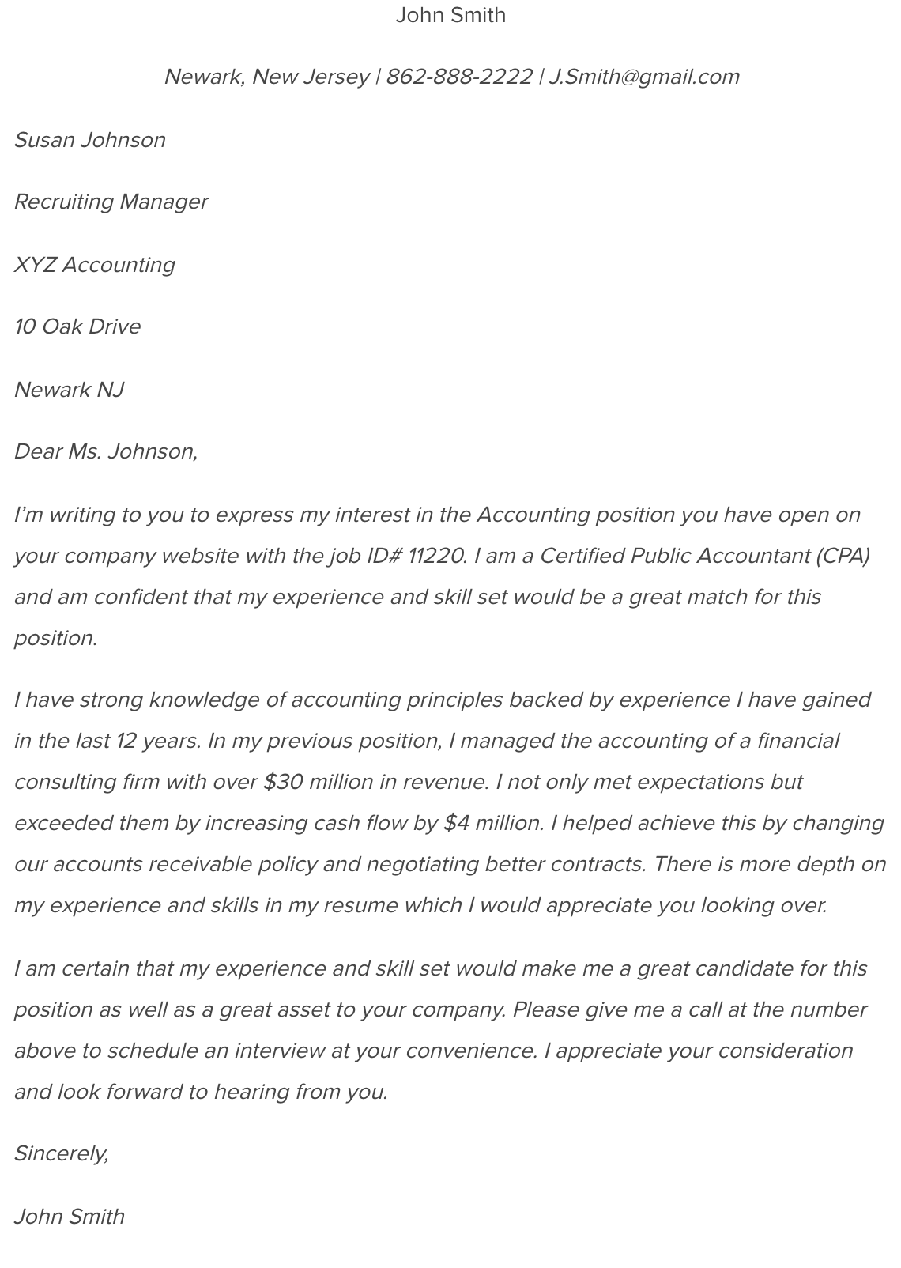

Dear

I am writing to inquire about the opening for …..

I offer X years of experience , I have … skills

The top portion of my attached resume highlights my career profile and three significant accomplishments that are also in alignment with this position.

I’d welcome the opportunity to speak with you if you feel I’d be a strong candidate for this or any position in your organization.